**Problem Statement**

How might we help professional exhibition lovers in Shanghai to sift through various exhibitions so that they can easily choose the exhibitions that meet their specific requirements on theme/time/location, etc.?

**Plan**

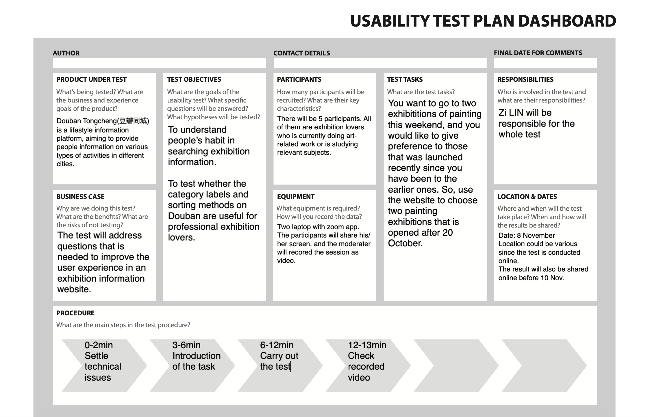

**Result Summary**

**Effectiveness (competion rate)**

All participants turned to the search box first. However, none of them find the answer there. So, one of them change the search term, another two of them went back to homepage and turned to the link-based navigation. There was also one participant stuck in that stage and failed to complete the task.

As a result, the completion rate is 80%.

**Efficiency (e.g. time to complete)**

The longest time spent is 5min 13s, the shortest is 2min 46s.

The average time used is 3min 23 s.